Mathematics Methods Investigations

Year 12

Topic 4.2: Continuous random variables and the normal distribution

Authors: Rom Cirillo
Margaret Denham
Jo Giumelli
James Heseltine

Editors: Rom Cirillo
Ann Shugg

For each topic three types of tasks are included:
Extended investigation – an investigation which could be done in the student’s own time followed by an in-class validation. Solutions are provided where practicable for the preparation activity/investigation. For the in-class validation, there are solutions and marking keys which identify the mathematical behaviours that students may exhibit.
In-class investigation – an investigation for which no prior preparation is required. Solutions and marking keys are provided.
Investigative questions – a series of short questions which test the student’s ability to apply their learning, to justify their conclusions, to investigate and to generalise, or to solve problems. Such questions could be included in a response or examination assessment. Solutions and marking key are provided.

Screen shot have been produced using the CASIO ClassPad II emulator or the ti-nspire CAS emulator.

Most graphs and diagrams have been produced using efofex software.

© The investigations and solutions in this publication are for the sole use of staff and students of the purchasing school. It is a breach of copyright to distribute them in whole or part in any form now or in the future to any other school, company or person.

Contents:
MATHEMATICS METHODS: Year 12
3.1 Further differentiation and applications
Task 1: Extended investigation: The second derivative
Task 2: In-class investigation: Taylor series
Task 3: Investigative questions

3.2 Integrals
Task 4: Extended investigation: Area between functions
Task 5: In-class investigation: Areas between graphs and the x-axis
Task 6: Investigative questions

3.3 Discrete random variables
Task7: Extended investigation: Distribution of sample means
Task 8: In-class investigation: Binomial distribution
Task 9: Investigative questions

4.1 The logarithmic function
Task10: Extended investigation: Logarithms
Task 11: In-class investigation: The logarithm function
Task 12: Investigative questions

4.2 Continuous random variables and the normal distribution
Task13: Extended investigation: The Normal distribution curve
Task 14: In-class investigation: Continuous distribution curves
Task 15: Investigative questions

4.3 Interval estimates for proportions
Task16: Extended investigation: TBA
Task 17: In-class investigation: TBA
Task 18: Investigative questions

This package only contains the investigations associated with topic 4.2: Continuous random variables and the normal distribution

If your school has purchased the complete set of 18 investigations, you will be informed when the rest are ready for delivery/download.

TASK 13: THE NORMAL DISTRIBUTION CURVE

Extended Investigation

Unit 4

Topic 4.2: Continuous random variables
and the normal distribution

Course-related information

The concepts and skills included in this investigation relate to the following dot points within the WA Mathematics Methods syllabus.

General continuous random variables
4.2.2 examine the concepts of a probability density function, cumulative
distribution function, and probabilities associated with a continuous random
variable given by integrals; examine simple types of continuous random
variables and use them in appropriate contexts
4.2.4 examine the effects of linear changes of scale and origin on the mean and
the standard deviation
Normal distributions
4.2.5 identify contexts, such as naturally occurring variation, that are suitable for
modelling by normal random variables
4.2.6 identify features of the graph of the probability density function of the normal
distribution with mean and standard deviation and the use of the standard
normal distribution
4.2.7 calculate probabilities and quantiles associated with a given normal
distribution using technology, and use these to solve practical problems

The ability to choose and use appropriate technology to enhance and extend concept development are also incorporated within some of the items.

Background information
Students need to be familiar with the mean and its properties and understand the basic principles of the standard deviation. Students will also be assumed to be competent in limits and integration, including the Fundamental Theorem of Calculus (syllabus points 3.2.15 to 3.2.17.

Competence with a CAS calculator is also assumed, specifically: finding limits, evaluating definite integrals, graphing functions and collating data points of a function
to be able to draw its graph.

Task conditions
Students have a take home section of the investigation that they can work on for several days. If the learning programme permits, providing significant class time for students to familiarise themselves with the task is recommended. In so far as the take home preparation activity covers the key concepts related to normal distributions it can be used to substitute a significant portion of in-class learning on the topic. Doing so can be used to compensate for its considerable length. Students then have an in-class assessment on the content of the investigation.

Students should not be permitted to take their investigative material into the class test.
It is essential that students bring their CAS calculator to the in-class validation.

NOTE:
The in-class assessment consists of two parts:

Questions 1 and 2 are calculator free

and Questions 3 and 4 are calculator assumed.

Calculators should NOT be used until Questions 1 and 2 have been collected.

Acknowledgement:

The wheat yield data for five hundred 10-acre lots is taken from Mercer W.B, Hall A.D 1911. The experimental error of field trials, J. Agric. Sci. 4, 107-132
The Normal Distribution

Extended Investigation Part 1: Preparation activity

In an agricultural sciences study, five hundred 10-acre plots of land were prepared and tended in identical fashion for a wheat crop. At harvest, the size of the crop yield of each plot was recorded in bushels.

The crop yield of the plots was found to be normally distributed with a mean of 3.9 bushels and a standard deviation of 0.45 bushels.

Question 1
Consider the function
This is equation of the graph of the standard normal distribution with mean =0 and standard deviation = 1

This function may be conveniently entered into a CAS calculator for convenient recall and calculation. For a Casio Classpad the syntax is:
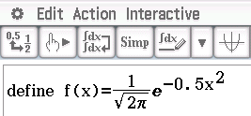
(a) Use your calculator to assist you to graph on the axes below

(b) The graph of is known as the probability density function for the standard normal distribution.
Use your calculator to find the limit of as to determine how the function behaves relative to the x-axis.

(c) With reference to your graph in part (a).
(i) Why is significant?

(ii) Label the crop yields in bushels at the bottom of the graph in line with the corresponding standard deviations of the x-axis.

(d) What do you expect the area to beneath the curve to be?

(e) Verify your answer in part (d) by evaluating on your calculator.
Using the Classpad, this can be done efficiently ashas already been defined.
Use the syntax:
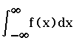
Similarly, determine and
Explain this result with respect to part (c) & (d).

Question 2
(a) is a probability density function (PDF) with
being the area under . Using this interpretation,
(i) explain the integral in terms of both area and probability.

(ii) explain what represents.

(b) Define on your calculator and
(i) graph for on the axes below.
Note: this function is too demanding for the graphing features of your calculator.

(ii) show crop yields in bushels along the bottom of the graph

(c) This graph is a cumulative distribution function (CDF). Use limits to determine the behaviour of as and explain this behaviour.

(d) Given that , interpret .

Question 3

Cumulative distributions effectively represent cumulative probabilities and these are commonly overlaid onto the probability density function.

(a) Use appropriate integrals to determine the proportions of the shaded regions for the PDF’s shown below.

(b) Research and explain briefly the 68-95-99.7 rule.

Question 4
When considering the crop yields we can think about the yields in one of two ways:
- The raw score measurements, i.e. a particular quantity of bushels harvested.
These are known as the X-scores.
- The number of standard deviations a particular quantity is above or below the mean. These are known as the z-scores.

This equivalence has been reinforced each time you scaled the crop yield (X-scores) against the standard deviations (z-scores) in Questions 4 & 5. Converting from the X-scores to the z-scores is known as standardizing the scores.

You have already performed these calculations informally. For example, in the case of our wheat crops we know
So a yield of
Thus, i.e two S.D.’s above the mean (μ).
Whilst, i.e. one S.D. below the mean (μ).

(a) Determine and/or research the formula to convert from an X-score to a z-score

(b) Convert the following X-scores to z-scores using .

(i)

(ii)

(iii)

(iv)
Question 5

The 68-95-99.7 rule is obtained by considering z-scores to the nearest whole standard deviation. In this question we will refine it down to the nearest ½ σ.

Using the z-scores calculated in Question 7, shade and state the proportion of the distribution that is:
(a) “Left-tailed”
when X < 4.125
(b) “Right-tailed”
when X > 3.225
(c) “Centred”
when 3.675 < X < 4.125

(d) “Bounded”
when 3.450 < X < 4.575

(e) Two crop yields have their calculated as and .
What is the probability of:
(i) a harvest yield of .
(ii) a harvest yield of .
(iii) a harvest yield with .
Determine the actual yields (i.e. X-scores) in bushels for each .

Using The Cumulative Distribution Function

Determining the Cumulative Distribution Function (CDF). beyond the nearest ½ S.D. requires a more accurate chart, or the use of task specific features on a CAS calculator.

Question 6
Graphical: z-score to probability (x-axis y-axis)
(a) Label the X-scores in intervals of 1 standard deviation across the top of the above graph.

(b) For each of the following questions, draw construction lines on the CDF above to show your solution.

What would the probability be of a crop harvest yielding the following?
(i)
(ii)

(ii)

Question 7
CAS Calculator: z-score to probability (x-axis y-axis)
is computationally intensive. So CAS calculators have specialized functions to handle these calculations more efficiently and
automatically standardize scores, using the cumulative distribution function to calculate left & right tailed and centred cumulative probabilities.

Notation: To indicate that a variable score X is part of a normal distribution we use the
notation: .
Thus for our data set with
For example: To determine the proportion of scores below we write
Thus on a Classpad calculator: - a “left-tailed” cumulative probability - is found thus:
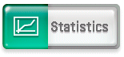
Start the
stats app
1
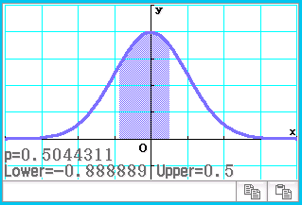
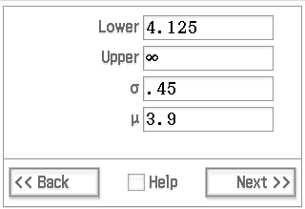
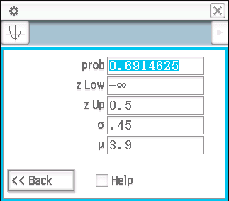
DON’T FORGET:
• Activate keyboard
• Resize screen
5
Bounded P(3.5 < X < 4.125)
Left tail P(X < 4.125)
z-scores
optional graph
Left tail P(X < 4.125)
4
Right tail P(X > 4.125)
2
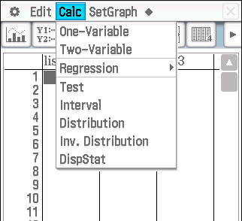

3

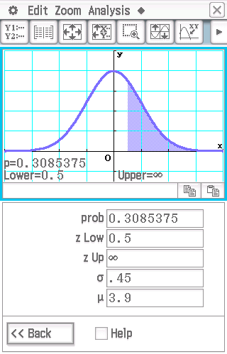
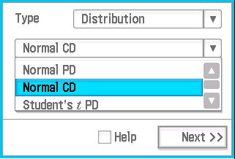

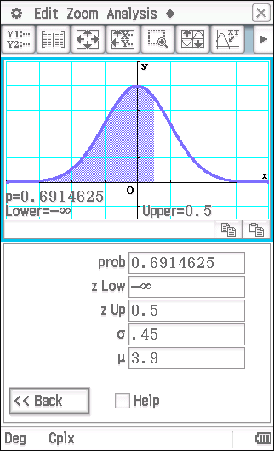

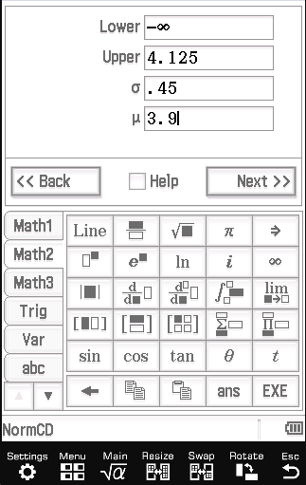

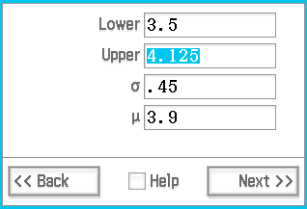

The Normal Distribution :
Use your calculator to determine the following (to 4 d.p.)
(a)

(b)

(c)

Question 8
Graphical: Probability to z-score (y-axis x-axis)
Refer back to the graph of the cumulative distribution function (CDF) on page 19 to answer the following questions. Draw construction lines on the CDF for each question to show your solution.

(a) A farmer determines that lowest 35% of harvests are not financially viable.
(i) What does this correspond to?
(ii) Hence, what is the minimum harvest (in bushels) to be profitable?

(b) The top 10% of harvests are considered to be too improbable for use in
calculating a projected income range.
(i) What is the maximum harvest (in bushels) that can be considered?

(ii) Given that the wheat fetches $8.50 per bushel what would be the expected
return (as a range) on a random plot of land?
(Exclude the lowest 35% and the top 10% of the harvests.)

Question 9

CAS Calculator: Probability to z-score (y-axis x-axis)
In Question 11 we needed to work out what z-score corresponded to a
given cumulative probability. We did so by reading the Normal Cumulative
Distribution off the y-axis and, using the CDF matched it up with a z-score
on the x-axis.

Notation
Example: To find the z-score with a Normal Cumulative Distribution of 72%,
we write
k is the unknown z-score – note that this is a “left tailed” problem.
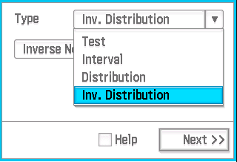
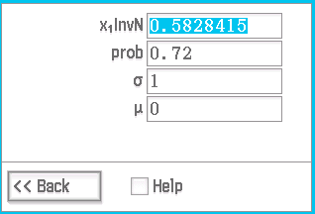
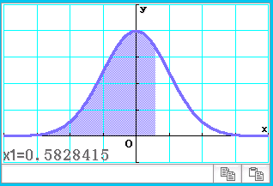
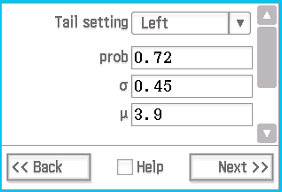
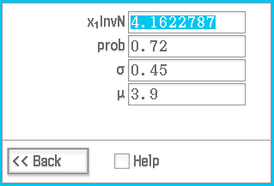
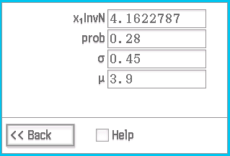
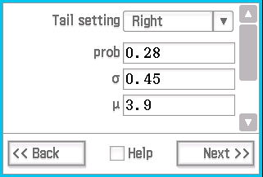
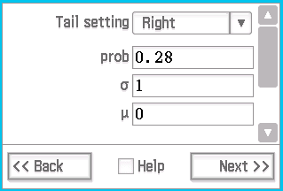
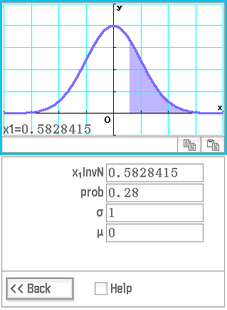
1
2
Left tail P(Z < k)=0.72
NOTE
X-score z-score
• Putting σ=0.45 μ=3.9
will return X-scores
• Putting σ =1 μ =0
will return z-scores

OBSERVE
We can see that 72% of the crops will be below 4.16 bushels

And since 28+72=100 we didn’t need to the calculator to deduce that 28% of the crops will be over 4.16 bushels.

NB z-score = X-score
i.e. z=0.58=4.16 bushels

3
Left tail P(X < k)=0.72
Right tail P(Z > k)=0.28

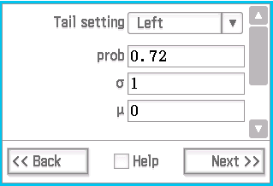

equivalent

Right tail P(X > k)=0.28
4

Inverse Normal CD.
Use your calculator to confirm and obtain more accurate answers (to 4 d.p.) for Question 11.
(a) A farmer determines that the lowest 35% of harvests are not financially
viable. What is the minimum harvest (in bushels) to be profitable?

(b) The top 10% of harvests are considered to be too improbable for use in
calculating a projected income range. What is the maximum harvest (in bushels) that can be considered?

(c) Given that the wheat fetches $8.50 per bushel,
(i) what would be the expected return (as a range) of a random plot of land?

(ii) From the 500 plots of land what would be the expected return in total.

End of Questions

Extended investigation Part 2: In-class validation

Total: 35 marks

NOTE: Calculator Free

Question 1 (12 marks)

A family-run business produces premium home made cordial sold in bottles labelled as containing 500mL. As a “start-up” business, they buy a second hand bottling machine from another business that has gone into liquidation.
The machine can be set to dispense a chosen volume, V. However, due to wear and tear it will dispense V mL of cordial only on average - sometimes more, sometimes less. The actual volume dispensed is normally distributed with a standard deviation of 5mL.

For example, if the machine is set to dispense V = 500mL, it won’t, in fact, always dispense 500mL, but it will dispense 500mL on average. The amount dispensed is normally distributed with and .

Consider the probability density function in the case where V = 500mL
(a) Along the axis at the top of the graph, label the X-scores (i.e. the volumes) that
correspond with each z-score that is 1, 2 or 3 standard deviations from the mean.
. (1)
(b) When the machine is set to dispense V = 500 mL,
(i) what is the probability that a bottle contains less than 500mL? (1)

(ii) what is the probability that a bottle contains 500mL, plus or minus 5mL?
(1)

(c) Market research reveals that customers will not tolerate buying a bottle that is
more than 5mL under volume.
(i) What z-score does this correspond to? (1)
(ii) What percentage of customers will be dissatisfied due to being sold less than
the labelled amount? (1)
(iii) Show this percentage on the normal distribution graph below. (1)
(d) The CFO (Chief Financial Officer – Mum) calculates that any bottles that are overfilled by more than 7.5mL will be financially unsustainable.
(i) What z-score does this correspond to? (1)
(ii) What percentage of bottles (due to overfilling) will be financially
unsustainable? (1)
(iii) Shade this on the normal distribution graph below. (1)
(e)
(i) What percentage of bottles will be of an acceptable volume based on the combined criteria of customer satisfaction and financial sustainability? (1)
(ii) Shade this on the normal distribution graph below. (1)
(f) Comment on the practicality of setting the machine to dispense V= 500mL. (1)

Question 2 (10 marks)

Use the graph of the cumulative distribution function below to answer the following questions.
The Chief Financial Officer concludes that while customers may be prepared to tolerate bottles that are up to 5mL below the labelled value, setting the machine to dispense 500mL and rejecting any bottles below 495mL would lead to so many rejected bottles the business would not survive.

It is decided that the bottling machine needs to be set to dispense at a higher average volume.

(a) The CFO decides that the business can only absorb a rejection rate of 2.5% of processed bottles due to under filling. Mark on the graph to show that this corresponds to a - score of –2. (1)
(b) Since the customers won’t accept anything less than 495mL on a bottle that is labeled 500mL, this must be set to correspond to an of 495mL. Using , label the rest of the across the top of the
graph. (1)

(c) What will be the value of the mean, ? (1)

(d) What volume should the machine be set to dispense under this scenario? (1)

(e) Discussion with the Board of Directors (around the dinner table) focused on the fact that, while fewer bottles were under filled, a whole lot more were now being overfilled. The Joint Chairs of the Board (Gran and Granddad) reminded the Board that the CFO (Mum) had worked out that they couldn’t afford to overfill (the labelled 500mL) by more than 7.5mL.

(i) What was this? (1)

(ii) What does this correspond to now? (1)
(iii) What percentage of bottles are being overfilled now? (1)
(f) Given that the probability density function is defined as:
Express the percentage of bottles that are being overfilled beyond the maximum tolerance as an appropriate integral of . (3)

NOTE: Calculator assumed
Question 3 (9 marks)

The Board Meeting was adjourned and everyone went to bed, except the CTO (Chief Technology Officer – Dad), who decided to put in some overtime. Whilst surfing the net he stumbled upon a software upgrade for their bottling machine that, along with recalibrating, reduced the standard deviation for a given dispensed volume to 2.375mL (i.e. ).

That weekend Jessie, fresh from studying normal distributions at school, was deputised, along with a calculator, to help the CFO & CTO to recalculate the situation.

(a) Jessie convinces the CFO that, given the improved accuracy of the bottling machine they can afford a rejection rate of 5% of bottles being under-filled
(i.e. under 495mL).

(i) To 4 decimal places, what will this correspond to? (1)
(ii) Justify that this will make the mean 498.907mL (2)

(iii) What volume can the machine now be set to dispense? (1)

(b) When and the CFO still allows an over fill of 7.5mL over the 500mL label, what percentage of bottles are being over filled?
(1)

(c) Hence:
(i) determine (to 3d.p.) what percentage of bottles fit the criteria of customer satisfaction and financial sustainability. (1)

(ii) express this as an appropriate integral of . (3)

Question 4 (4 marks)

After being recalibrated the machine will gradually lose accuracy and the standard deviation will increase over time. If the machine has to be recalibrated when the rejection rate reaches 8%, what standard deviation will this occur at?
Give your answer to two decimal places.

End of questions
Extended investigation Part 1: Preparation activity

Solutions

Question 1
Solution
(a)
X-scores 2.1
4.35
4.8
5.25
5.7
3.45
3
2.55

(b) The curve is asymptotic to the x-axis, since:

(c) (i) corresponds to the position of the mean. It is the centre of the
distribution.
(ii) shown on the graph as X-scores

(d) The total area amounts to the total population as a proportion, i.e. 100% = 1.00.

(e) is the centre of the curve, in one case the upper boundary of the lower half, and in the other case the lower boundary of the upper half.
Total area is 1.0, so the area of each half will be 0.5.

Question 2
Solution
(a) (i) This integral will calculate the area under the PDF from its lowest extreme
up to the value k. Since the total area under the PDF = 1, this represents a
proportion of the population and, hence, a percentage and a probability.

(ii) P(x) formulates a probability function that gives the probability of a score
being in the area below the upper boundary of x.
(b) (i)
(ii)
X-scores 2.1
5.7
5.25
4.8
4.35
3.45
3
2.55

(c)

(d) P(b) is the probability of a score being below ‘b’,
P(a), the probability of a score being below ‘a’ and
P(b) – P(a) the probability of a score falling within the area bounded at the lower end by ‘a’ and at the upper end by ‘b’.

Question 3
Solution
(a) (i) (ii)
(iii)

(b) For a normally distributed population, 68% of the population will fall within ±1S.D.
of the mean, 95% will fall within ±2 S.D’s and 99.7% will fall within ±3 S.D.’s

Question 4
Solution
(a)

(b) (i)

(ii)

(iii)
(iv)

Question 5
Solution
(a) i) X < 4.125 69.1%
(b) X > 4.35 15.9%
(c) 3.675 < X < 4.125 38.2%

(d) 3.450 < X < 4.575 77.4%

(e) (i) 15.9%
(ii) 6.7%
(iii) 22.6%
z=-1 X=3.45 bushels
z=1.5 X=4.575 bushels

Question 6
Solution
(a)

(b) (i) 10%
(ii) 96%
(iii) 96 – 10 = 86%

Question 7
Solution
(a) 0.1333

(b) 0.9869

(c) 0.1201

Question 8
Solution
(a) (i)
(ii)
(b) (i)
(ii)

Question 9
Solution
(a)

(b)
(c) (i)
(ii)

The normal distribution curve

Extended investigation Part 2: In-class validation

Question 1 (a)
Solution
515
510
505
485
490
495
Mathematical behaviours | Marks
- correlates z-scores to X-scores: | 1

Question 1 (b)
Solution
(i)
(ii)
Mathematical behaviours | Marks
- (i) recognises as half of the distribution  - (ii) correlates z-scores to X-scores and tallies the percentages | 1  1

Question 1 (c)
Solution
(i)
(ii)
(iii)
Mathematical behaviours | Marks
- (i) correlates X-score to z-score  - (ii) tallies appropriate percentages  - (iii) recognises context as ‘left tail”, shades appropriately | 1  1  1

Question 1 (d)
Solution
(i)
(ii)
(iii)
Mathematical behaviours | Marks
- (i) correlates X-score to z-score  - (ii) tallies appropriate percentages  - (iii) recognises context as ‘right tail”, shades appropriately | 1  1  1

Question 1 (e)
Solution
(i)
(ii)
Mathematical behaviours | Marks
- (i) recognises as the complement of parts (a) & (b) combined  - (ii) recognises context as ‘bounded’, shades appropriately | 1  1

Question 1 (f)
Solution
Over 20% (i.e. more than a fifth) of the bottles are being rejected. This is not a good business model.
Mathematical behaviours | Marks
- identifies >20% bottles rejected and interprets within context as unfeasible. | 1

Question 2 (a) & 2 (b)
Solution
505
515
510
495
485
490
500
525
520
(b)
(a)
(e)
Mathematical behaviours | Marks
- (a) identifies appropriate value on y-axis and projects to x-axis.  - (b) recognises translation of X-scores relative to z-scores and labels  appropriately | 1  1

Question 2 (c), 2 (d) & 2 (e)
Solution
(c)
(d) Machine should be set to dispense 505 mL
(e)
(i) 507.5 mL
(ii) z = 0.5
(iii)
Mathematical behaviours | Marks
- (c) recognises the translation of X-scores relative to z-scores and  correlates the mean (X-score) to z=0.  - (d) interprets and transfers the understanding to the context at hand  - (e) (i) identifies the 7.5mL overfill limit as relative to the label target  500mL , not the mean = z =0 = 505mL  - (ii) converts translated X-score to new z-score  - (iii) identifies appropriate value on x-axis and projects to y-axis for  cumulative probability and identifies complement is needed. | 1  1  1  1  1
`

Question 2 (f)
Solution
Mathematical behaviours | Marks
- recognises integral bounds as relative to z-score = 0.5  - recognises integral as complement of ‘left tail’ with lower bound = OR ‘right tail with upper bound = .  - identifies multiplying constant of 100 to produce a percentage. | 1  1  1

Question 3 (a)
Solution
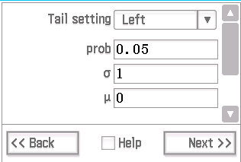
(i)
(ii)
(iii) Machine can be set to dispense 498.907mL

Mathematical behaviours | Marks
- (i) obtains correct score  - (ii) substitutes appropriately into z-score formula  solves equation correctly  - (iii) interprets result relative to context. | 1  1  1  1

Question 3 (b)
Solution
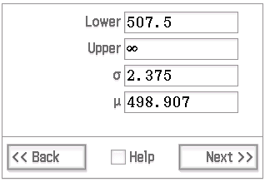
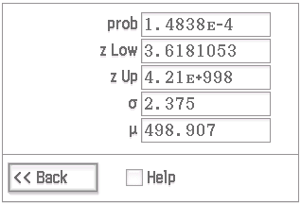

Mathematical behaviours | Marks
- Determines correct percentage | 1

Question 3 (c)
Solution
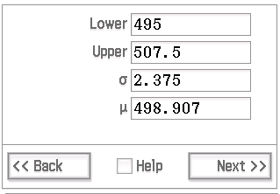
(i)
(ii)

Mathematical behaviours | Marks
- (i) obtains correct percentage  - (ii) identifies z-score for upper bound of integral  - identifies z-score for lower bound of integral  - introduces multiplying constant of 100 to produce percentage. | 1  1  1  1

Question 4
Solution
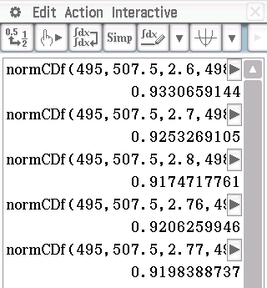
Mathematical behaviours | Marks
- determines acceptance rate from rejection rate  - uses CAS to perform trial and error solution, recording process  - obtains upper and lower bound for first decimal place  - uses CAS to refine solution to second decimal place | 1  1  1  1

TASK 14: CONTINUOUS DISTRIBUTION CURVES
In-Class Investigation

Unit 4

Topic 4.2: Continuous random variables
and the normal distribution

Course-related information

The concepts and skills included in this investigation relate to the primarily to following dot points within the WA Mathematics Methods syllabus.

General continuous random variables
4.2.2 examine the concepts of a probability density function, cumulative
distribution function, and probabilities associated with a continuous random
variable given by integrals; examine simple types of continuous random
variables and use them in appropriate contexts
4.2.4 examine the effects of linear changes of scale and origin on the mean and
the standard deviation

Normal distributions
4.2.6 identify features of the graph of the probability density function of the normal
distribution with mean and standard deviation and the use of the standard
normal distribution

The ability to choose and use appropriate technology to enhance and extend concept development are also incorporated within some of the items.

Assumed Knowledge
While the above dot points are the main focus, this investigation assumes that the following syllabus points have been covered.

3.2.4 establish and use the formula
3.2.12 interpret the definite integral as the area under the curve
3.2.15 examine the concept of the signed area function
4.19 define the natural logarithm
4.1.10 examine and use the inverse relationship of the functions and

Background Information

This investigation would be best delivered towards the end of the topic on continuous random variables. It would be appropriate for students to already have some level of familiarity with both the exponential distribution and the normal distribution prior to undertaking this investigation.

Task conditions

This task should be at done under test conditions.

Use of a Casio Classpad calculator has been assumed and it is expected that students will use it extensively to perform cumulative probability calculations. It would be advisable to modify references to and instructions for the Classpad with appropriate instructions for the CAS calculator used in your school.

In class Investigation Total: 21 marks

Parameterised Distribution Functions

Consider the quadratic function as stated in turning point (or vertex) form
are called the parameters of the function.

This can also be denoted:

The notation on the left hand side of the equality sign therefore signifies a function, that is a function of with parameters . denotes the family of quadratic functions of that have been transformed by .

Question 1 (9 marks)
The graph of the probability density function of a normal distribution is a bell shaped curve defined by

where parameters $μ$ and $σ$ are parameters, $μ$ representing the mean and
$σ$, the standard deviation of the distribution.

Like the quadratic function, we can consider the family of bell curves that occur when the function undergoes transformations such as change of scale or change of origin.

(a) Which parameter represents change of scale and which parameter represents change of origin? (1)

(b) Show that the function below is equivalent to the function given above. (1)
f ( x; $μ,σ)$ = $\frac{1}{\sqrt{2πσ^{2}}} e^{- \frac{{(x-μ)}^{2}}{2σ^{2}}}$

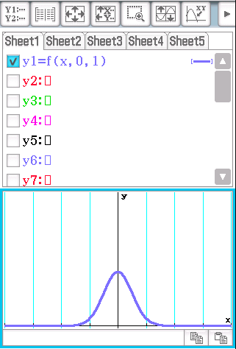
On a Casio Classpad calculator, the parameterised function can be written
on the screen in Main as follows:
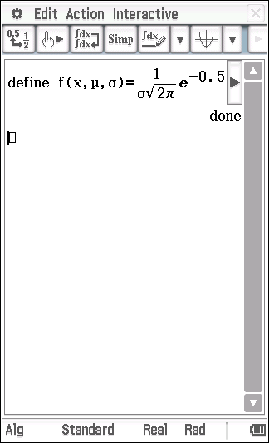

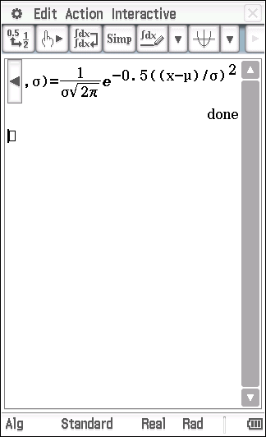

The probability distribution function of the standard normal distribution with $μ$ = 0 and $σ$ = 1 can then be graphed by writing the parameterised function shown on the screen shot above.

(c) On your calculator simultaneously show the graphs of the functions, f( x, 0, ) with standard deviation, , = 1, 2 and 0.5.
Neatly sketch these 3 graphs on the unscaled axes below. (2)

(d) What would be the expected area beneath each of these graphs? (1)

(e) Delete the factor from the denominator of the function you defined in your calculator in part (d), so that it becomes

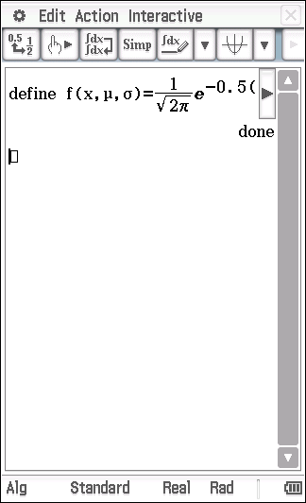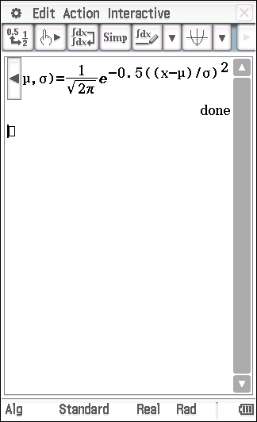

Draw the graphs of this function on your calculator for = 1, 0.5 and 2.

Compare them to the 3 graphs drawn in part (c) and comment on any differences. (1)

Using the Casio Classpad notation
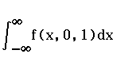
will enable you to carry out the calculations in part (f)

(f) Determine the integral of f ( x; $μ,σ)$ = $\frac{1}{ σ \sqrt{2π}} e^{- \frac{ 1}{ 2 }({\frac{ x-μ }{σ})}^{2}}$
when - $∞$ < x < $∞$, with and standard deviations, $σ,$of 1, 0.5 and 2,

(i) without as a factor in the denominator. (1)

(ii) with as a factor in the denominator. (1)

(g) What do you conclude is the purpose of the factorin the denominator of the equation: ? (1)

generates a family of bell curves that are the result of transforming
f ( x; $μ,σ)$ = $\frac{1}{ σ \sqrt{2π}} e^{\frac{-1}{ 2 }( {\frac{x-μ }{σ})}^{2}}$ by adjusting the parameters .

The Normal Distribution is a symmetrical distribution and, as such, it is apparent that the mean, median and mode are concurrent. This need not be the case for non-symmetrical distributions.

Question 2 (7 marks)
Exponential distributions are not symmetrical and have a probability density function defined by:
(a) Determine an expression for , the cumulative distribution function for the exponential distribution for . (2)

(b) Consider the case where for
(i) State the probability density function, f(x,1). (1)

(ii) State the cumulative distribution function. (1)

(c) The graph of , is drawn below. Shade on the graph. (1)

(d) Hence, or otherwise, determine the median of . (2

Question 3 (5 marks)
The mean, , of any continuous probability distribution is given by
(a) In the case of the exponential distribution, , why is the lower bound equal to zero? (1)

(b) Use your calculator and the given integral for $μ$ to determine the mean for the exponential distribution with a probability density function defined to be
. (1)

(c) Hence, or otherwise, for an exponential distribution with a parameterised probability density function defined as, suggest an expression for the mean.
Consider at least 2 further values of before deciding on the expression. (2)

generates a family of curves that are the result of transforming
by adjusting the parameter,

(d) Does the mean = the median for all exponential distributions even though exponential distributions are not symmetrical?
Answer this question by comparing the mean and median of the exponential distribution when . You have evaluated these 2 statistics already in this investigation. (1)

End of questions
Solutions and Marking key
Question 1 (a) (b) (9 marks)
Solution
(a)
(b)
Mathematical Behaviours | Marks
- (a) matches parameters correctly  - (b) manipulates symbolically to show algebraic equivalence of  expression | 1  1

Question 1 (c) (d)
Solution
(c)
(d)
Mathematical Behaviours | Marks
- (c) illustrates relative size of 2 graphs in sketch  - illustrates relative size of 3rd graph in sketch  - (d) recognises that an area of 1 must be preserved as the graph  changes. | 1  1  1

Question 1 (e) (f) (g)
Solution
(e)
Area beneath all of the curves is no longer 1
(f)
(g)
The factor of in the denominator clearly preserves an area of 1
Mathematical Behaviours | Marks
- (e) with or without a sketch, identifies that area =1 is not preserved  without .  - (f) evaluates appropriate integrals to verify that area =1 is not  preserved without  - evaluates appropriate integrals to verify that area =1 is preserved  with .  - (g) identifies purpose of the factor ofin denominator of | 1  1  1  1

Question 2 (a) (7 marks)
Solution
Mathematical Behaviours | Marks
- identifies an appropriate integral for the CDF  - integrates over appropriate bounds and simplifies correctly. | 1  1

Question 2(b)
Solution
(i) (ii)
Mathematical Behaviours | Marks
- (i) interprets the parameterised function correctly.  - (ii) uses the result from part (a) with | 1  1

Question 2 (c), (d)
Solution
(c)
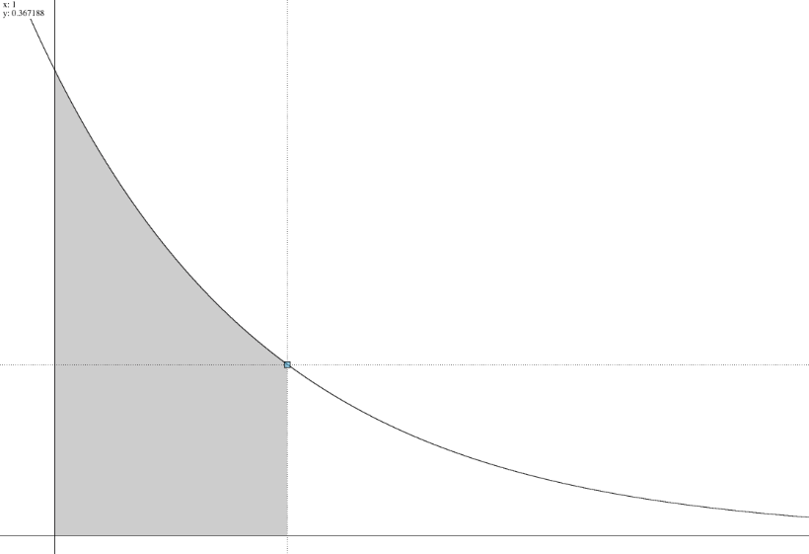
x
(d)
Mathematical Behaviours | Marks
- (c) illustrates clearly the variable as the upper boundary of the  shaded region, .  - (d) states an appropriate equation to determine the median  - determines correct solution to this equation. | 1  1  1

Question 3 (5 marks)
Solution
(a)
(b)
has a mean of 1
(c)
(d) When , which has mean = 1 [Qu 3 (b)] and
median = ln 2 [Qu 2 (d)].
So mean median for all exponential distributions.
Mathematical Behaviours | Marks
- (a) gives the correct reason.  - (b) evaluates correctly the appropriate integral for the mean of the  - distribution  - (c) shows evidence of multiple trials  - infers from multiple trials that the mean is  - (d) makes correct conclusion.. | 1  1  1  1  1

End of Marking key

TASK 15: THE NORMAL DISTRIBUTION CURVE

Investigative Questions

Unit 4

Topic 4.2: Continuous random variables
and the normal distribution

Course-related information

The concepts and skills included in this investigation relate to the following dot points within the WA Mathematics Methods syllabus.

4.2.2 examine the concepts of a probability density function, cumulative
distribution function, and probabilities associated with a continuous random
variable given by integrals; examine simple types of continuous random
variables and use them in appropriate contexts
4.2.4 examine the effects of linear changes of scale and origin on the mean and
the standard deviation
4.2.6 identify features of the graph of the probability density function of the normal
distribution with mean and standard deviation and the use of the standard
normal distribution

The ability to choose and use appropriate technology to enhance and extend concept development is also incorporated within some of the items.

Background Information
Students should have an understanding of the probability density functions and cumulative probability functions of continuous random variables and knowledge of the normal distribution. The two tasks offer different approaches to cover the same content.

Task conditions
The first task (Question1) is calculator free and the second (Question 2) assumes the use of a CAS calculator. Each task should be undertaken under test conditions.

Question 1 (15 marks)
CALCULATOR FREE
The curve of the standard normal distribution is defined by the probability density function:

where each value on the x-axis represents a given .

The probability of a random z - score being less than a particular z - score is defined by the cumulative distribution function:

which is equivalent to

(a) As is the area beneath to the left of a particular z – score, interpret the integral . (2)

(b) When the indicated transformations are performed on function, ,
determine the effect on the area beneath the graph of f(x).

(i) (1)

(ii) (1)

(iii) (2)

(c) Because is a probability density function,
Use your results from part (b) determine the value of (2)

so

and can be written as

For P(z) = to be a cumulative distribution function,
must be equal to 1.

(d) Refer to your conclusion in part (c) and determine the value of
that enables the expression to have the value of 1.
(2)

Note: =

Because P(z) = is a cumulative distribution function,
f(x) = is a probability density function.

(e)
The probability density function of the normal distribution
with mean, and standard deviation, ,
and defined by
f ( x) = $\frac{1}{ σ \sqrt{2π}} e^{-0.5( {\frac{x-μ }{σ})}^{2}}$,
is obtained by a combined transformation on
f ( x) = $\frac{1}{ \sqrt{2π}} e^{-0.5x^{2}}$,
the probability density function of the standard normal distribution

Follow the steps below to see if the transformations d, c and k applied to
f ( x) = $\frac{1}{ \sqrt{2π}} e^{-0.5x^{2}}$,
in this investigation confirm the above statement.

Consider f(x) = from part (d)

(i) State each of the transformations d, c and k in terms of $σ$ or$μ$ . (2)

(ii) Write the expression for f(x) replacing d, c and k with the appropriate transformation of $σ$ or$μ$ (2)

(iii) Has the statement in the box at top of the page been confirmed?
State your conclusion, giving a reason. (1)

Question 2 (11 marks)
CALCULATOR ASSUMED

The curve of the standard normal distribution is defined by the probability density function:

where each value on the x-axis represents a given.
The probability of a random being less than a particular is given by
the cumulative distribution function:
which is equivalent to
0$≤$P(z) $≤1$
(a) As gives the area beneath to the left of a
particular z – score, interpret the integral .
(2)

(b) On a CAS calculator define the function then, by trialling some of the given values of , determine the effect on the integral in each case.

(i) for (1)

(ii) (2)

(c) Hence, or otherwise, determine the effect of on . (1)

(d) Hence, or otherwise, given that , write a suitable integral for . (2)

(e) Hence, or otherwise, by considering and a suitable integral, justify that the probability density function of any normal distribution is given by where $μ$ represents the mean and $σ$ represents the standard deviation of the distribution. (3)

Solutions
CALCULATOR FREE
Question 1 (a) (15 marks)
Solution
Mathematical Behaviours | Marks
- identifies the definite integral as a difference of cumulative probabilities.  - interprets as the probability of a score falling between the upper and lower bounds. | 1  1
Question 1 (b)
Solution
(i)
(ii)
(iii)
Mathematical Behaviours | Marks
- (i) recognises that a translation will not affect area beneath a curve.  - (ii) recognises that a dilation will affect the area.  - (iii) recognises that in the combined transformation, only the dilation will  affect the area.  - states the factor of the change in area | 1  1  1  1

Question 1 (c)
Solution
Mathematical Behaviours | Marks
- realises value of integral is area beneath given function.  - relates transformations to Question 1(b) part (iii) and recognises that the value of the integral is rather than 1 | 1  1

Question 1 (d)
Solution
If then
so

Mathematical Behaviours | Marks
- writes integral from part (c) equated to its value  - states correct value for k | 1  1

Question 1 (e)(i) and (ii)
Solution
(i) , and
(ii) f(x) = $\frac{1}{σ }×\frac{1}{ \sqrt{2π}} e^{-0.5( {\frac{1 }{σ}(x-μ)}^{2}}$

(iii) Concludes that the given statement is confirmed as the 3 transformations used
result in the equation of the probability density function of the normal distribution
Mathematical Behaviours
- (i) states correct parameter for 2 transformations  - states correct parameter for 3rd transformation  - (ii) substitutes parameters correctly for 2 transformations  - substitutes parameter correctly for 3rd transformation  (iii) makes correct conclusion with a valid reason | 1  1  1  1  1

CALCULATOR ASSUMED
Question 2 (a) (13 marks)
Solution
Mathematical Behaviours | Marks
- Identifies the definite integral as a difference of cumulative probabilities.  - Interprets as the probability of a score falling between the upper and lower bounds. | 1  1

Question 2 (b)
Solution
(i)
(ii)
Mathematical Behaviours | Marks
- Recognises that horizontal translations do not affect area beneath  - Recognises that horizontal dilations affect the area beneath  - Recognises that the dilated area is changed by the factor of | 1  1  1

Question 2 (c)
Solution
Mathematical Behaviours | Marks
- Recognises that only the dilation will affect the area in the combined transformation. | 1

Question 2 (d)
Solution
Mathematical Behaviours | Marks
- Adjusts integral of to maintain an area of 1  - Restates the integral for | 1  1

Question 2 (e)
Solution
Mathematical Behaviours | Marks
- Recognizes the scale factor of when integrating  - Appropriately compensates by multiplying by to maintain area <1  - Rewrites integral including in the integrand to obtain the Gaussian Function. | 1  1  1

